**January 2025 Newsletter**

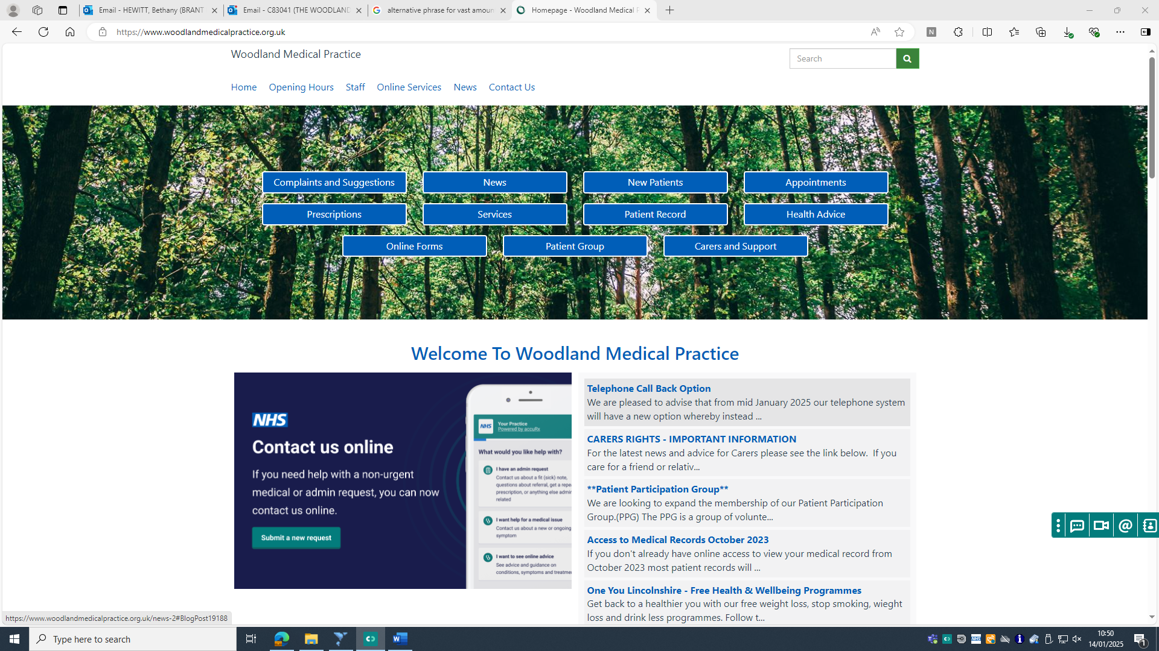

**Please visit our practice website**

[**www.woodlandmedicalpractice.org.uk**](http://www.woodlandmedicalpractice.org.uk)

**and follow the link for ‘Carers and Support’ to find extensive information for carers in the UK.**

**Are you a carer?**

**If so, there is a vast amount of help available to you, if you let us know. Please inform us if you are a working carer, young carer, or unpaid carer.**

**The practice will be closed from 1pm Tuesday 21st January for staff training. You will be advised to contact 111 for routine advice or 999 for emergencies.**

**Get Winter Strong – There is still time.**

We are still offering flu vaccines to eligible patients until March 2025, contact us to book in.

If you are unable to attend an appointment, please call to cancel. A lot of clinical time is wasted due to patients not attending appointments.

**January 2025 Newsletter**

**We are now on Facebook. Follow Woodland Medical Practice for regular updates and information. Be aware this is an informative platform only.**

Make sure your contact details are up to date. This helps us keep you informed of necessary information, such as annual reviews, results, appointments, and vaccine eligibility.

**Make use of our online service for non-urgent medical enquires by visiting the practice website.**

**The pharmacy first scheme can be an excellent way of receiving the medical assistance needed without the need to see a GP.**

**Friends and Family Survey**

We really appreciate patient feedback to help us progress the best we can as your General Practice. You can access the survey via our website or in the surgery.

Our December survey showed 82% of our patients rated us Very Good!

We are seeing a very large amount of pre-booked appointments being missed. These add to a significant number of clinical hours wasted. Please attend your appointments and cancel them if you know you won’t be able to attend.

**Missed Appointments**